UWC and Ignition SCADA

User Guide for setting up Ignition SCADA with UWC

August 2020

Revision 0.0

Contents

1.0 Introduction 3

2.1 Purpose 3

2.2 Scope 3

2.3 System Requirements 3

2.0 Ignition Installation Guide 4

2.1 How to install Ignition on Windows 4

2.2 Steps to install and configure MQTT Engine module 6

3.0 Install and Configure Ignition Designer 11

3.1 Steps to Install and Configure Ignition Designer 11

# Introduction

Ignition SCADA by Inductive Automation® combines an unlimited licensing model, with instant web-based deployment, and the industry-leading toolset for supervisory control and data acquisition (SCADA) — all on one open and scalable universal platform. Ignition is The New SCADA because it solves all the major pain points of old SCADA. Ignition empowers your business to easily control your processes, and track, display, and analyze all your data, without limits.

## Purpose

This document provides information on how to install Ignition Gateway and third-party modules. There are steps to configure Ignition Designer to visualize the data being sent by UWC Containers.

## Scope

This document aims to provide steps to install and configure Ignition SCADA with UWC.

## System Requirements

* Java 8+ (server), Java 6+ (client)
* Dual-Core Processor (32 or 64 bit)
* 4GB RAM
* 10GB free HD space

Also, ensure you have Administrator privileges to run the Ignition installer.

# Ignition Installation Guide

## How to install Ignition on Windows

This section provides steps to install ignition on a windows system.

**Pre-requisite:** Internet connection is required for Installation.

**Steps:**

1. Go to the Inductive Automation website at  
   [www.inductiveautomation.com](http://www.inductiveautomation.com/)
2. Download 8.015 (Stable). A **ignition-8.0.15-windows-x64-installer.exe** file will be downloaded. (Choose 32-bit version if your computer runs 32-bit windows)
3. Run the **ignition-8.0.15-windows-x64-installer.exe** to install Ignition on the system.

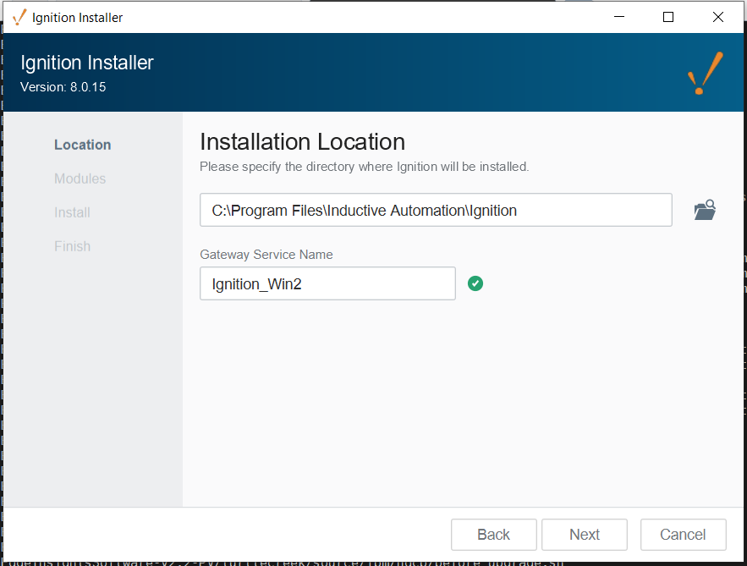

1. Click on Next and installation will start.

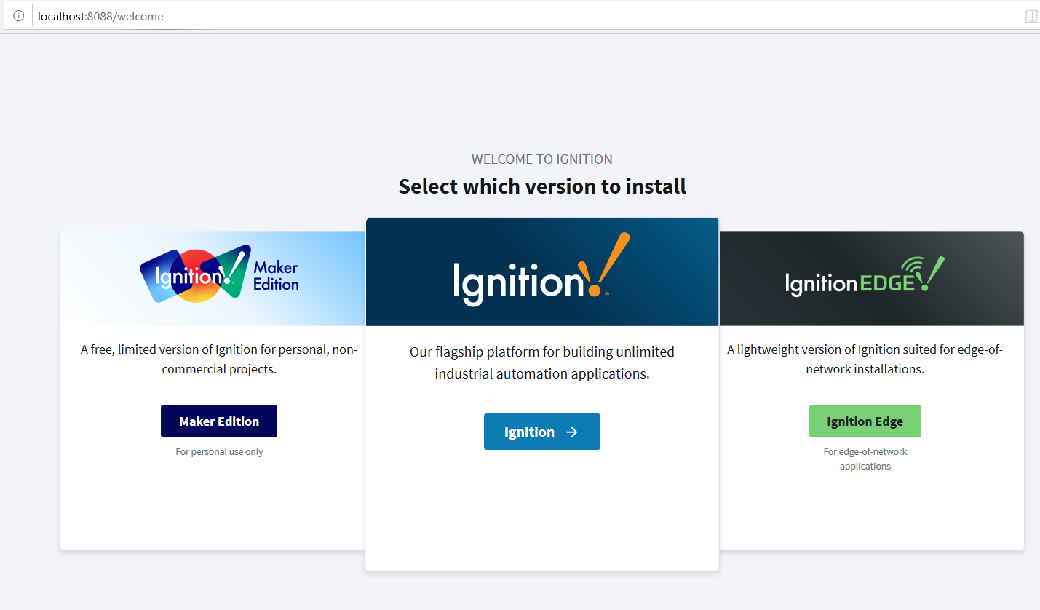

1. Choose Ignition.

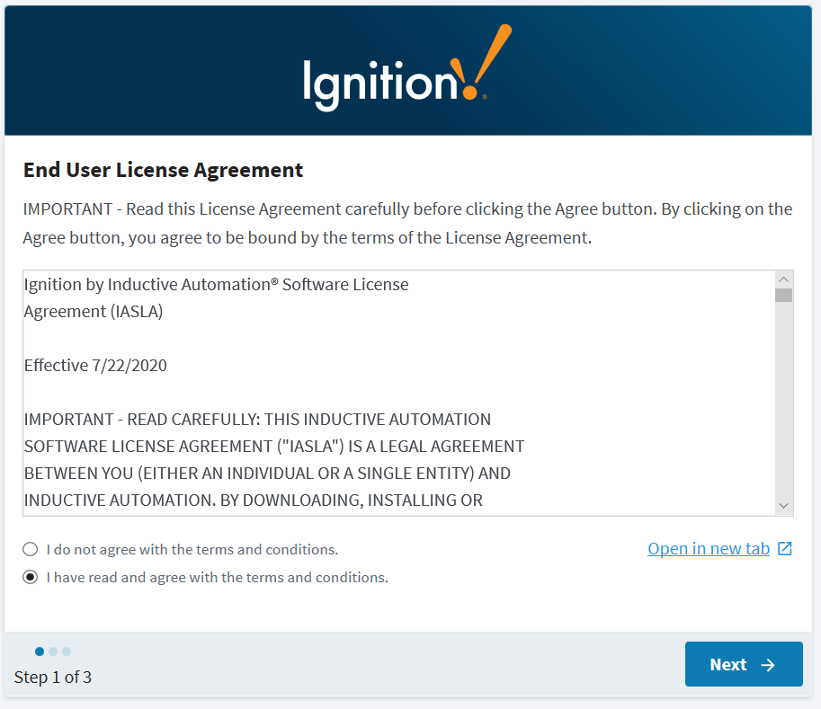

1. Click Next on license agreement window. You will be asked to create user credentials. Enter the username and password that you want to create and click next.
2. Enter the port number and then launch start the gateway.
3. Gateway web interface should open in your default browser. Link to <http://localhost:8088/web/home?9>

At this time, your gateway is ready to use. In order to use MQTT, you need to install MQTT Engine separately.

## Steps to install and configure MQTT Engine module

These are steps to MQTT Engine module in ignition gateway. You need MQTT Engine to connect and subscribe to MQTT Server.

Following are the steps,

1. Download MQTT Engine package file from <https://inductiveautomation.com/downloads/third-party-modules/8.0.15>

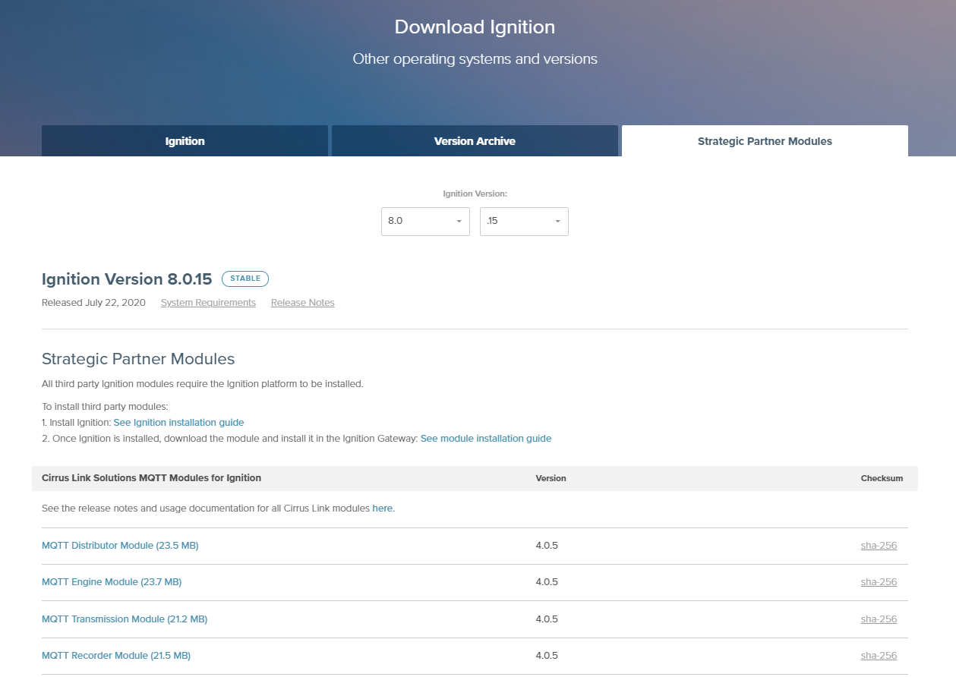

1. Once the “MQTT-Engine-signed.modl” file is downloaded. Go to Igntion Gateway. (<http://localhost:8088/web/config/system.modules?11>)
2. Click on **Config** and then click **Modules**.

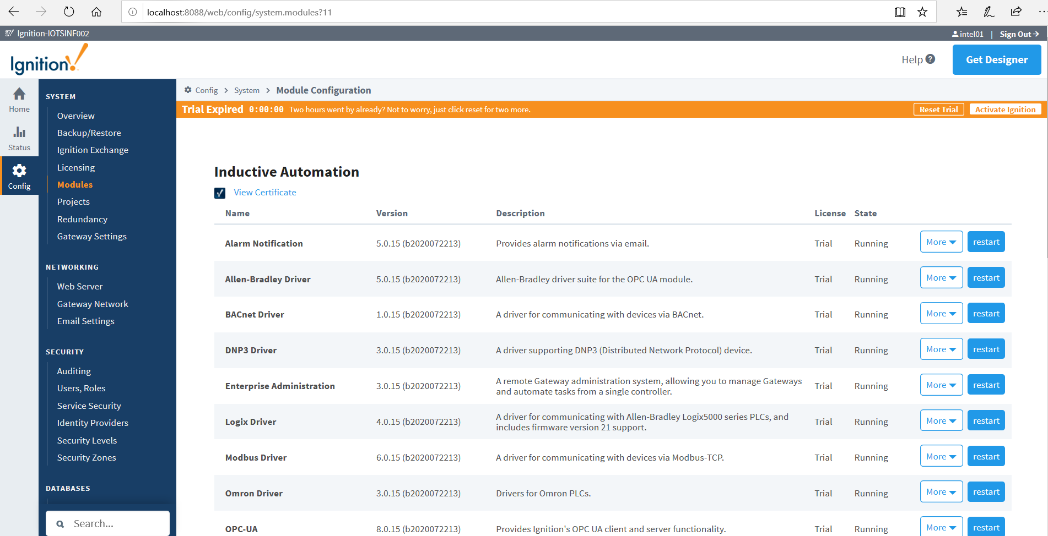

1. Scroll Down to bottom and you can see a link to install or upgrade a Module. Click on it and a new page will open to install the module.

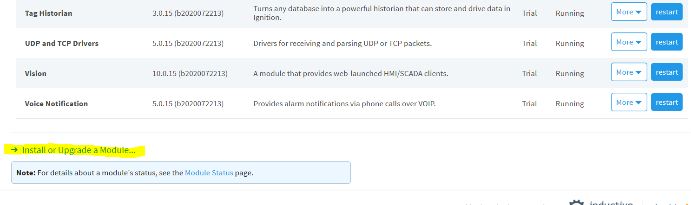

1. On this page, click on browse button and open “**MQTT-Engine-signed.modl** “ file. Then click Install.

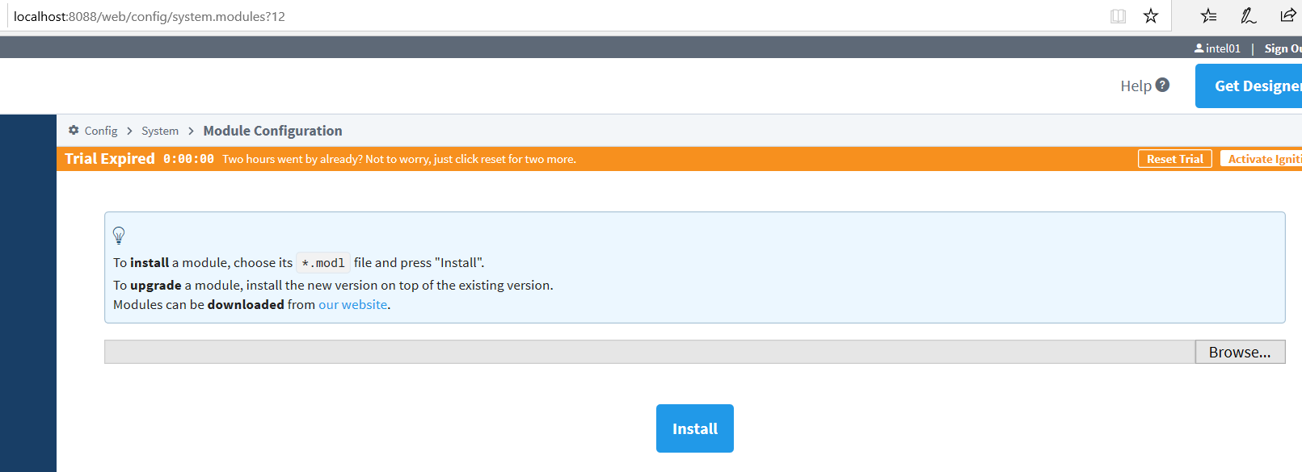

1. Read the Terms and License agreement and click **Accept.** This will install the MQTT Engine module and you can see that Modules.

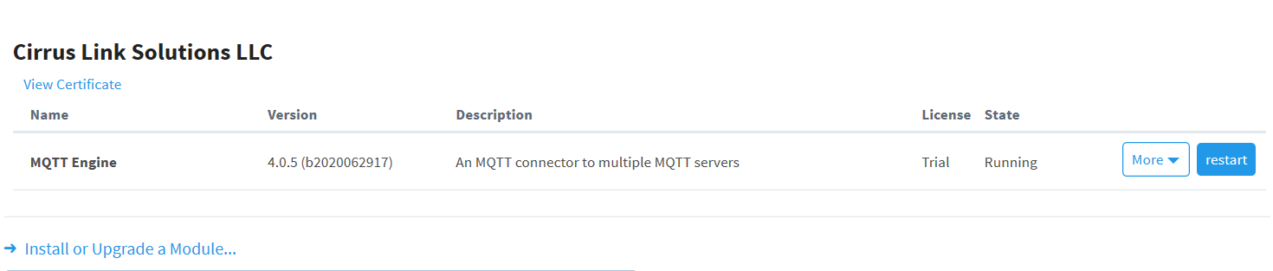

1. After the MQTT Engine module is installed, we need to configure it. Click Config > Settings.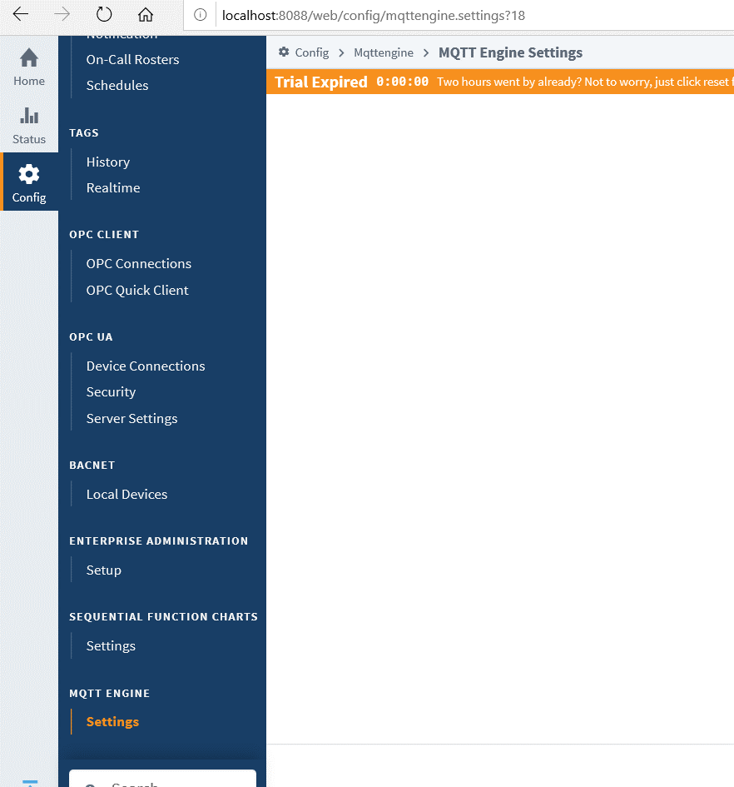
2. On the setting page, click on Servers tab and enter. Now you need to provide you MQTT server settings. To do so, click on Create new MQTT server settings or you can edit the default server config.

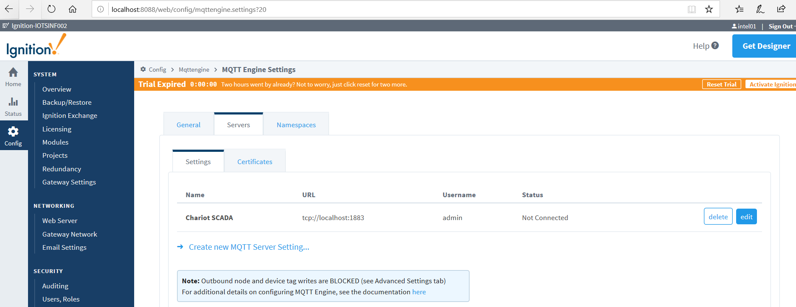

1. Enter the IP and port number. Enter TLS certificates details if MQTT server requires authentication. Finally click save changes.

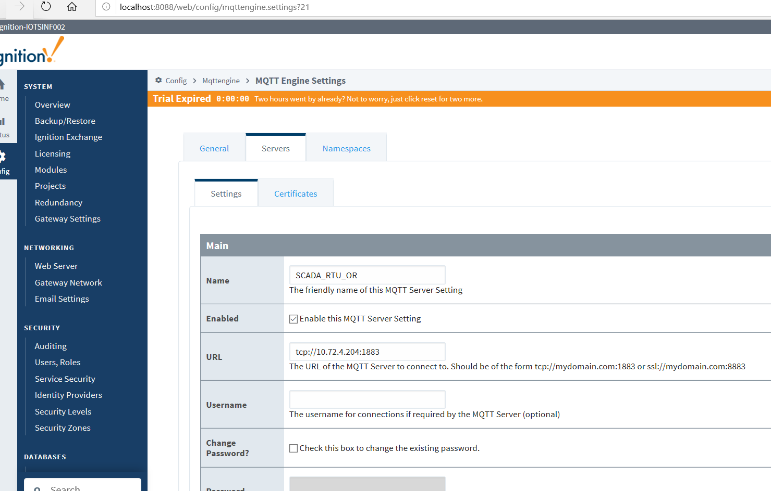

1. As soon as you do the changes, it should get connected to MQTT server. You can check it from servers tab.

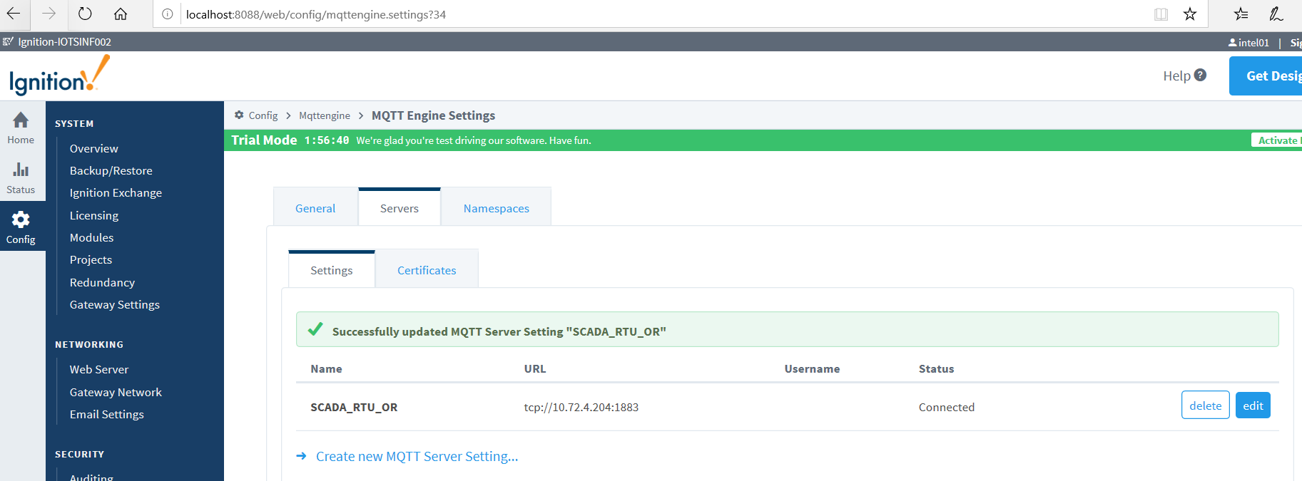

More can be found on <https://inductiveautomation.com/resources/video/mqtt-engine-module>

# Install and Configure Ignition Designer

Once you are connected to MQTT server, we need to configure a ignition designer to visualize UWC data in HMI. This section provides details about installing and configuring Ignition Designer.

### Steps to Install and Configure Ignition Designer

1. To install Ignition designer, click on the Get Designer button on Ignition Gateway page.

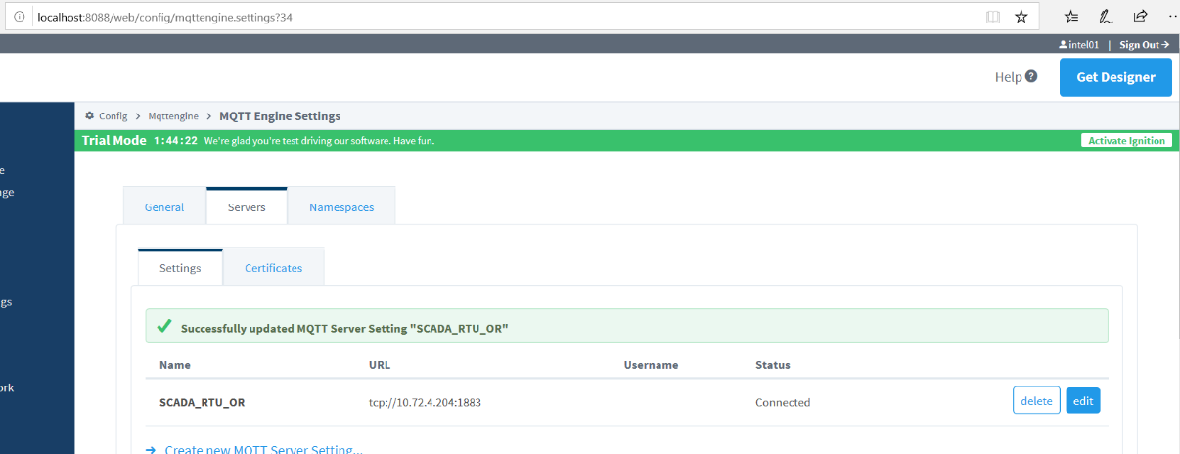

MQTT

1. You will be directed to download link. Click on the link to download the Designer Installer.

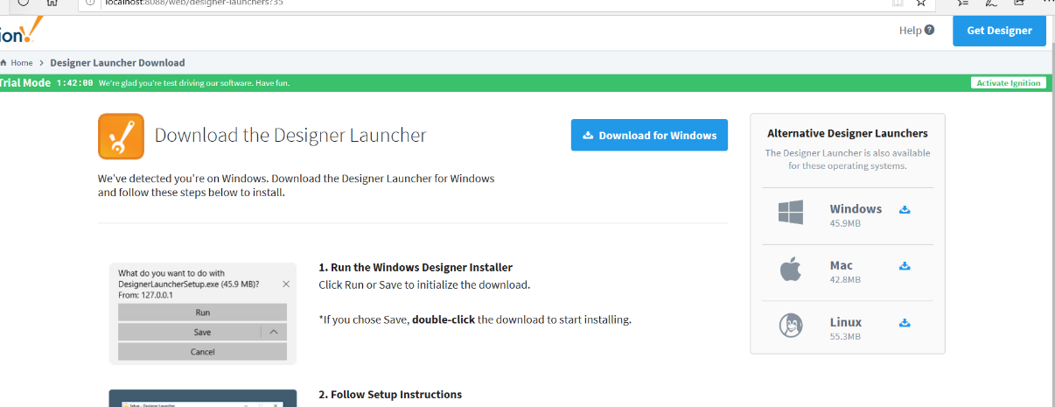

1. Once the installer file “**DesignerLauncherSetup.exe**” is downloaded, run it to install Ignition Designer.
2. After the installation is done, start the Ignition Designer Launcher.

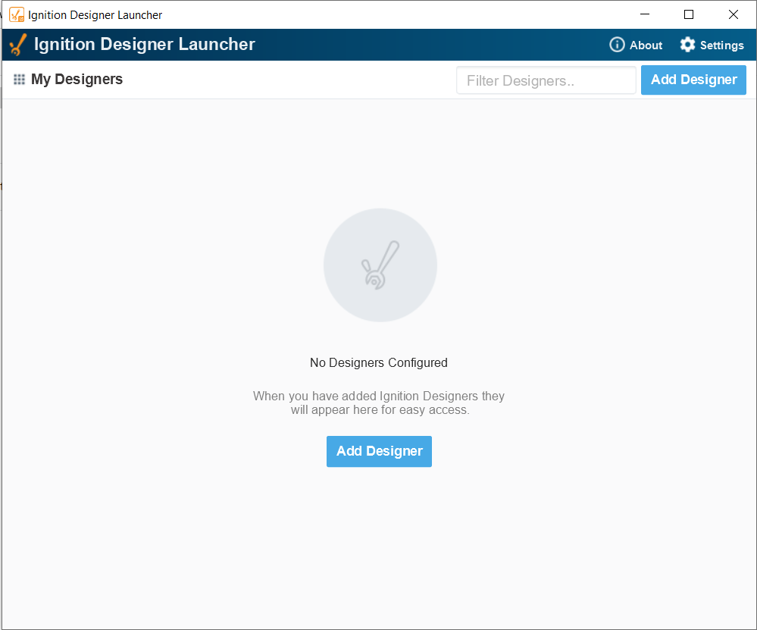

1. On Ignition Designer Launcher window, click on Add Designer to add a new designer.
2. Click on Manually Add Gateway to add a new Designer.

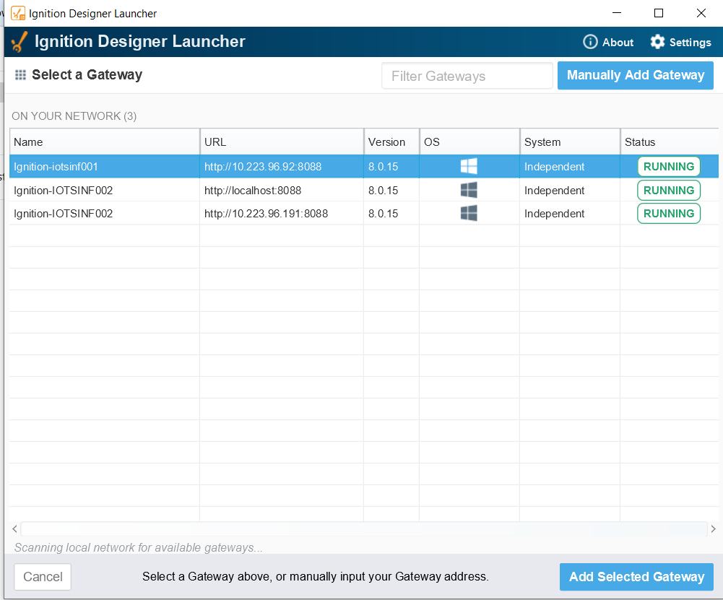

1. You will be prompted to enter Gateway URL. Enter the URL of the Gateway and click add Gateway.
2. 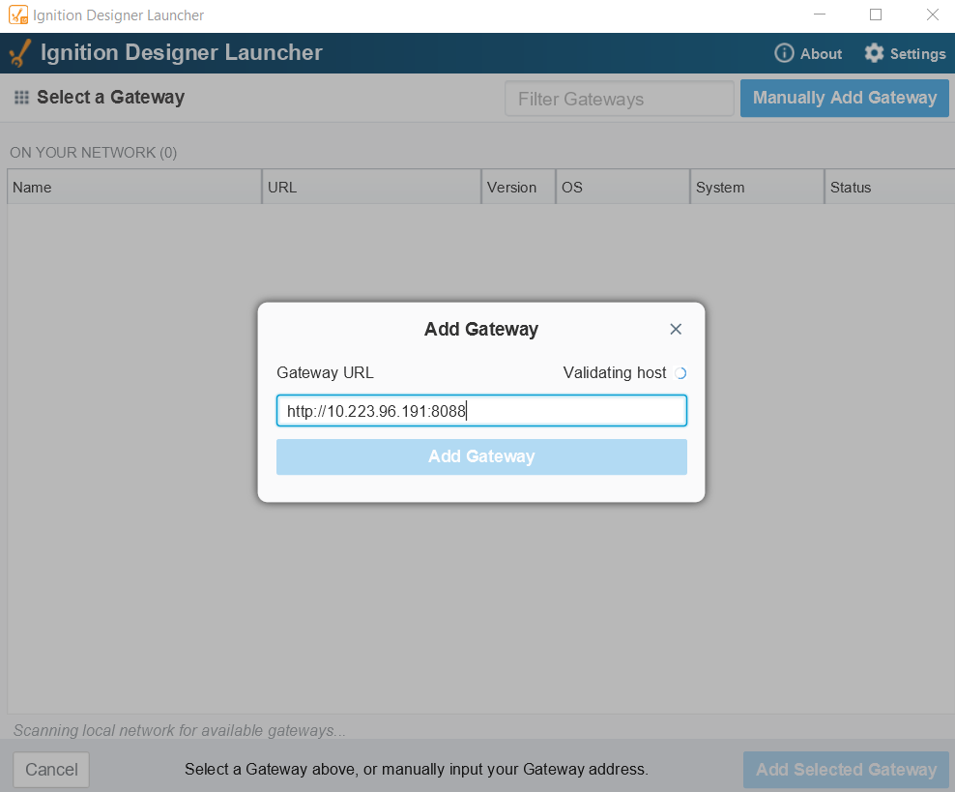After the Gateway is added, you can select your Gateway and launch Designer for it.

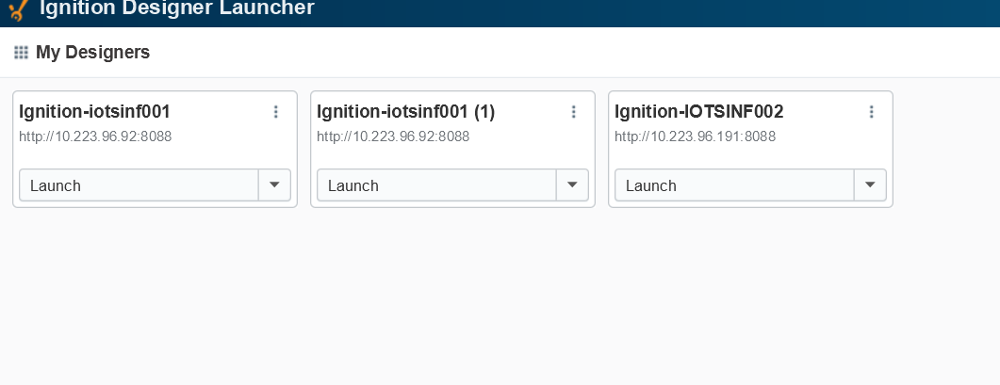

1. Enter the username and password that were set earlier. A new project widows will open.

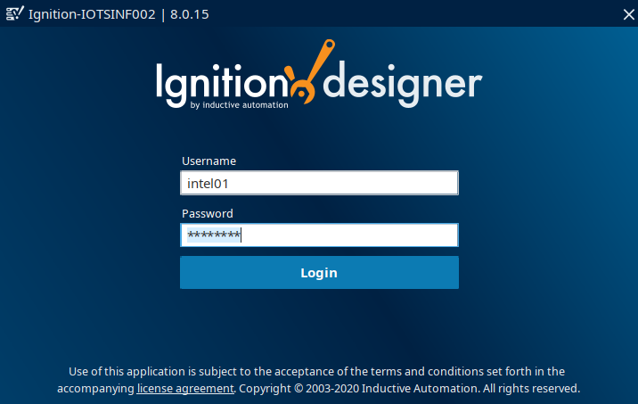

1. Click on New Project. A new project Setup window will show up. Enter details and click on Create New Project.

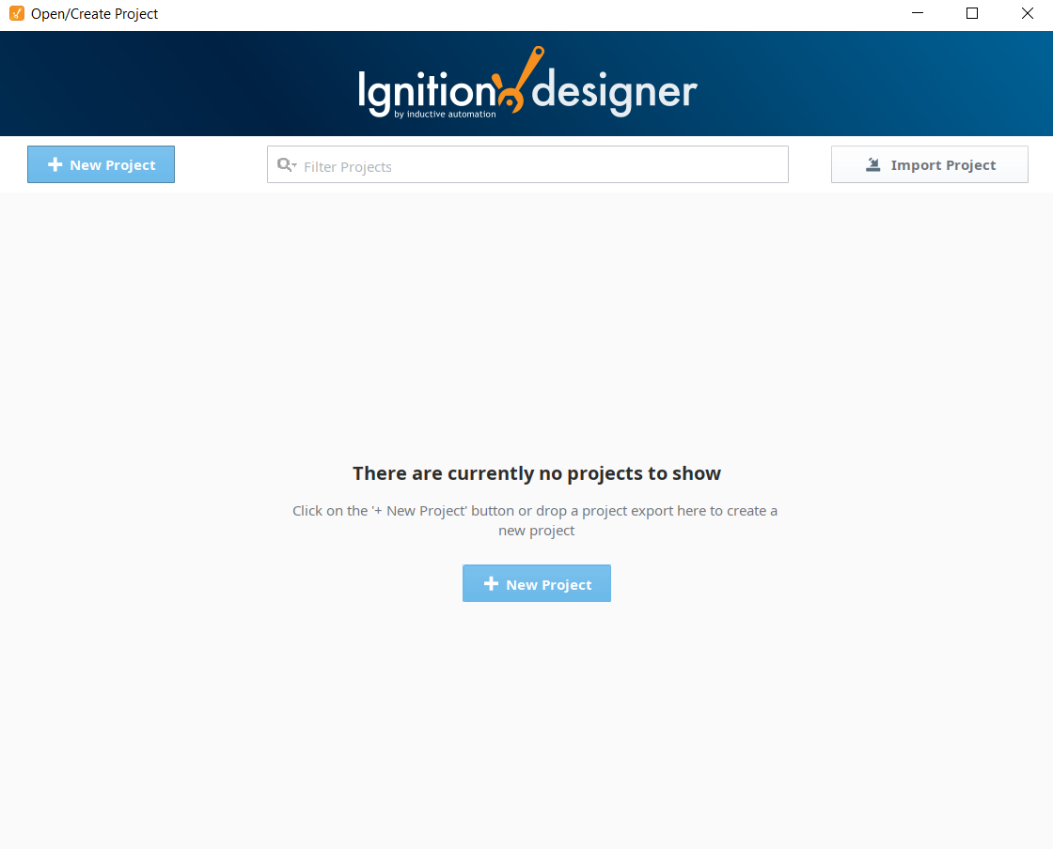

1. The Ignition Designer window opens and you can see the Tags under Provider directory tree.

